Assignment Problems: Day 10

The following problems require access to the file named ‘Dataset_Day10.csv’, provided with this assignment. (Use Random State = 50)
This is the same assignment data as Day 9.
The datasets include data from 768 women with several medical predictor variables and one target variable(‘Outcome’). The classification goal is to predict whether or not the patients in the dataset have diabetes or not.
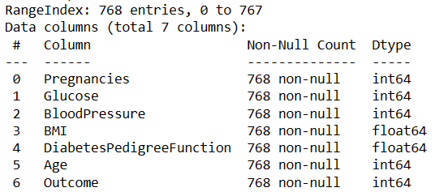
For columns:
Glucose,
BloodPressure,
BMI,
DiabetesPedigreeFunction
If the column value is 0, then they should be considered as missing data.
Problems to solve –
- Firstly, replace all Missing values with relevant figures.
- Then remove all existing outliers and get the final data for classification.
- Split the data into 80% training and 20% testing data. Then, use a Decision Tree classifier algorithm with target variable as ‘Outcome’.
  - Print the default model performance metrics: Accuracy, Precision, Recall, F1Score
  - Plot a Precision & Recall vs max_leaf_nodes & max_depth (consider a range of numbers for both parameters) curve (both Prec and Rec on the same graph). Find the parameter values for which F1-score is the highest. (Use ‘entropy’ as criterion)

